
Palmer Timeshare Claimants Group

April 2009

Dear

PALMER CLAIMANTS’ GROUP
MAY 2008 - BULLETIN

I am writing to update you on the latest developments. The delay in sending out this bulletin was because I was waiting to receive confirmation with regard to the sale of Tenerife Royal Gardens, to which I refer in more detail below.
Island Village Heights, Flamingo & Yucca Park
The position in relation to these resorts has not changed since the last bulletin. Following the sale of these resorts there remains approximately €3m due to be paid to the tax and local authorities in relation to these developments, with a further €1m payable in staff redundancy costs.
Los Olivos
Following the completion of the sale of this resort in August 2008, the Joint Trustees are receiving the sale proceeds of €8m in instalments. The final instalment is scheduled to be received in July 2009.
Tenerife Royal Gardens
The sale of TRG, which was due to complete in January 2009 but has been delayed by the purchaser who is experiencing difficulties in raising the necessary finance and the Joint Trustees cannot say with any degree of confidence whether the sale will proceed. As such, the Joint Trustees will now consider offers from other interested parties in the event that the current sale does not go through. At present, the next highest offer that has been received for this resort is significantly less than the current offer and the Joint Trustees are hoping that either the existing purchaser will be able to complete the sale transaction within the next couple of weeks or an improved offer will be received from another interested party.
Club La Paz
Lawyers are still in negotiations with the Spanish authorities in order to lift the criminal embargo over Club La Paz although the process is proving time-consuming.
We will write to you again in August 2009, unless there are any important developments to report to you in the meantime.

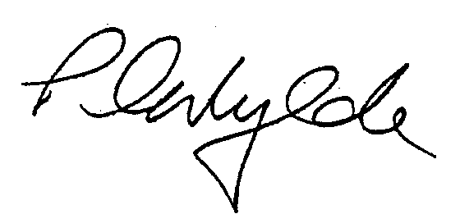
Yours sincerely

PETER WYLDE
PARTNER

